**Unlock the Future of Design: Experience Limitless Variants with VisCommerce 3D**

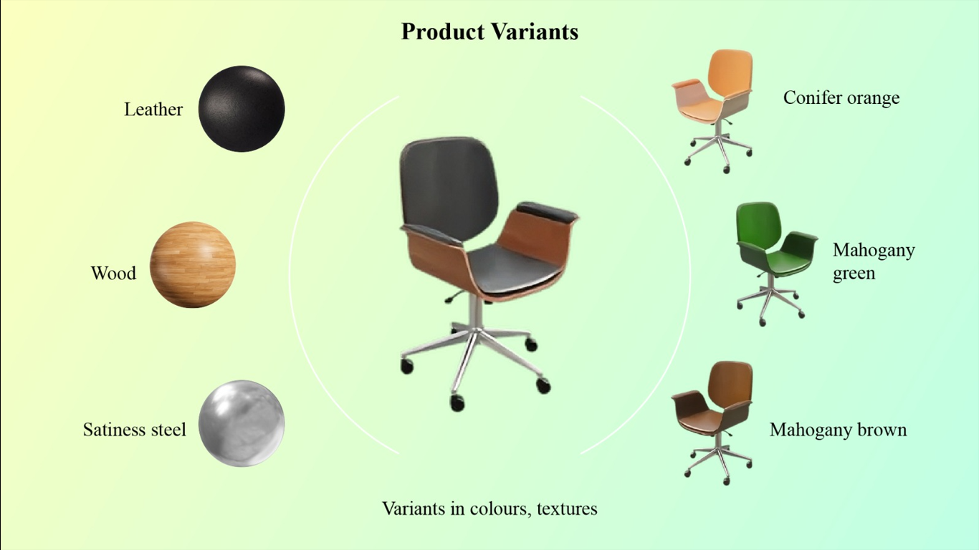

Dear [Recipient's Name],

We are thrilled to introduce you to our revolutionary VisCommerce solution that brings an immersive experience to both home and store environments. With our advanced technology, you can now explore an extensive range of product variants, including materials, colors, and textures, within a 3D environment.

**A World of Possibilities:**

Imagine having the ability to visualize furniture pieces in your preferred materials such as leather, wood, and stainless steel, all within the comfort of a virtual space. Our VisCommerce platform takes your interior design or store planning journey to the next level by allowing you to experiment with a diverse palette of options. Whether you're an individual looking to furnish your home or a retailer aiming to create captivating in-store layouts, our solution has you covered.

**Explore Variants with Ease:**

In the realm of home interior design, our VisCommerce technology offers a seamless experience. Suppose you're considering a new leather sofa for your living room. With just a few clicks, you can visualize how the same sofa design would look in luxurious wood or sleek stainless steel, each contributing a distinct aesthetic to your space. Moreover, the ability to explore different colors and textures empowers you to find the perfect combination that resonates with your style.

**For Retail Excellence:**

For retailers, VisCommerce introduces an innovative way to engage customers and streamline store planning. Imagine being able to showcase your products in various materials and colors, tailored to your target audience's preferences. Whether you're arranging a store layout or designing a window display, our 3D solution room planner enables you to curate an ambiance that aligns perfectly with your brand identity and customers' expectations.

**Examples Speak Louder:**

To illustrate the capabilities of our VisCommerce solution, I've attached a few screenshots showcasing furniture pieces in different variants. You'll notice how a simple change in material or color can drastically transform the overall feel of the space, offering endless opportunities for creativity.

I'd love to discuss how our VisCommerce solution can be integrated into your design or retail strategy. Please let me know a convenient time for a call or meeting, and I'll be delighted to provide a more detailed presentation and answer any questions you may have.

Thank you for considering our innovative technology. We look forward to the possibility of collaborating and revolutionizing the way you envision spaces.

**Best regards,**